**WEEK 1**

**Connect EC2 Ubuntu Using PuTTY (.ppk Key)**

**🧾 PREREQUISITES**

Make sure you have:

* ✅ EC2 **Ubuntu** instance running
* ✅**.ppk private key file**
* ✅**PuTTY installed (Windows)--**[**https://putty.org/index.html**](https://putty.org/index.html) **(INSTALL FIRST ONE)**

**🔹 STEP 1: Check Security Group**

Go to **EC2 → Security Groups → Inbound rules**

Ensure this rule exists:

Type: SSH

Port: 22

Source: My IP

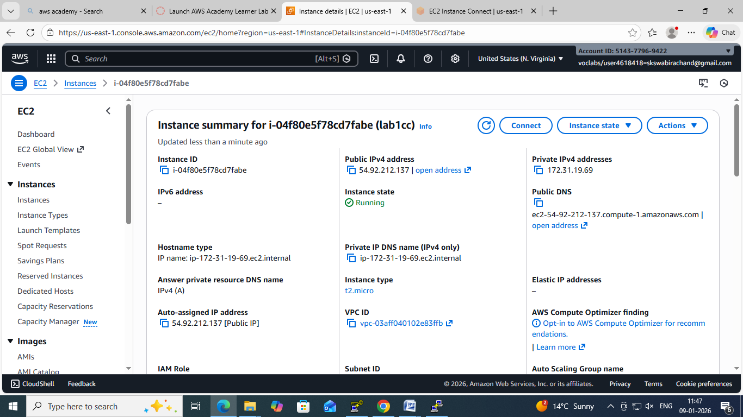

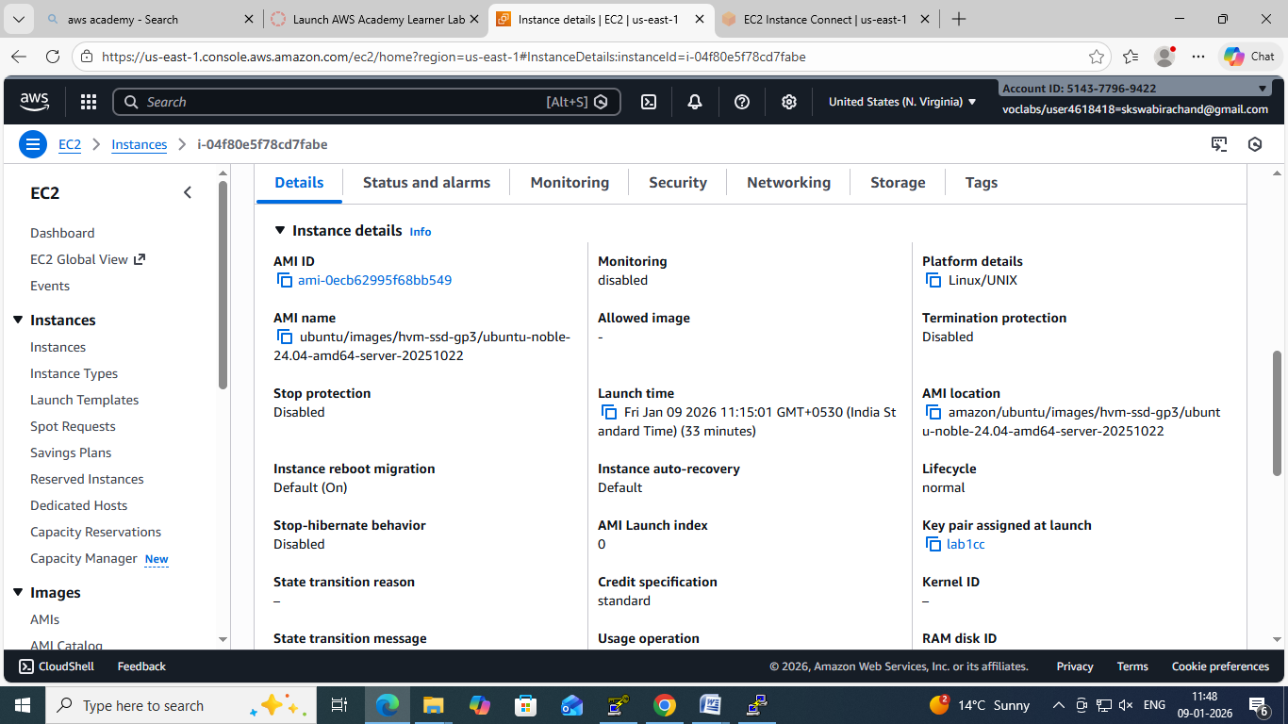

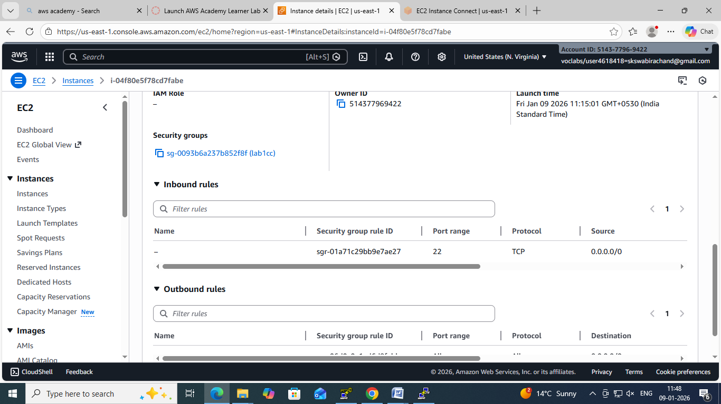

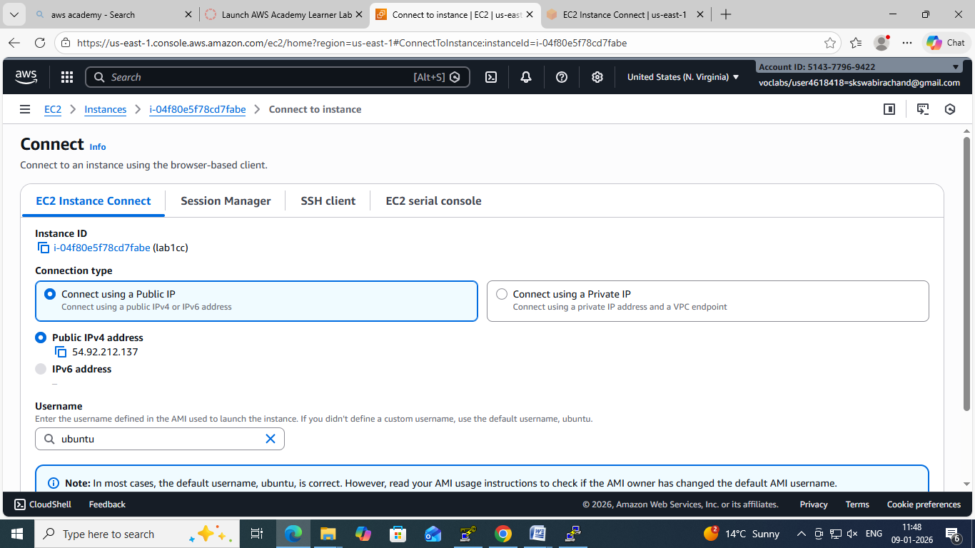

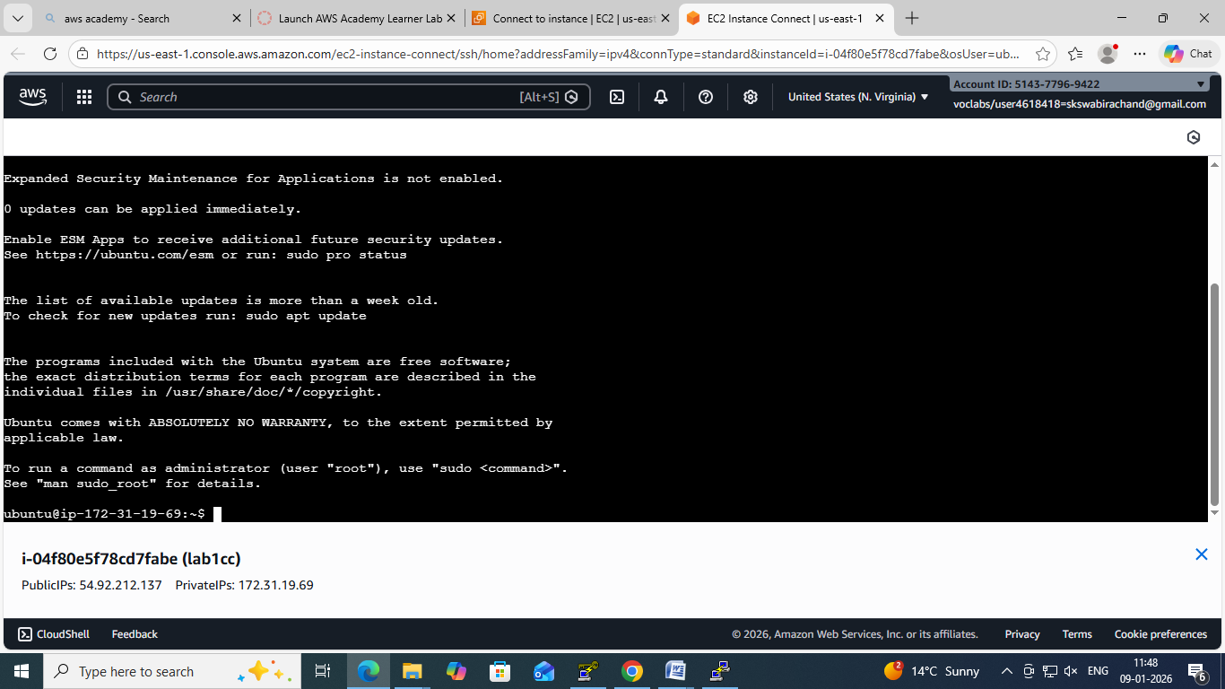

❌ If SSH is blocked → connection will fail

**🔹 STEP 2: Open PuTTY**

1. Launch **PuTTY**
2. In **Session** screen:

**Host Name (or IP address): EC2—CONNECT—COPY (DNS NAME)**

ubuntu@<PUBLIC-IP>

Example:

[ubuntu@3.110.xxx.xxx](mailto:ubuntu@3.110.xxx.xxx)

**🔹 STEP 3: Attach the .ppk Key**

In PuTTY left menu, go to:

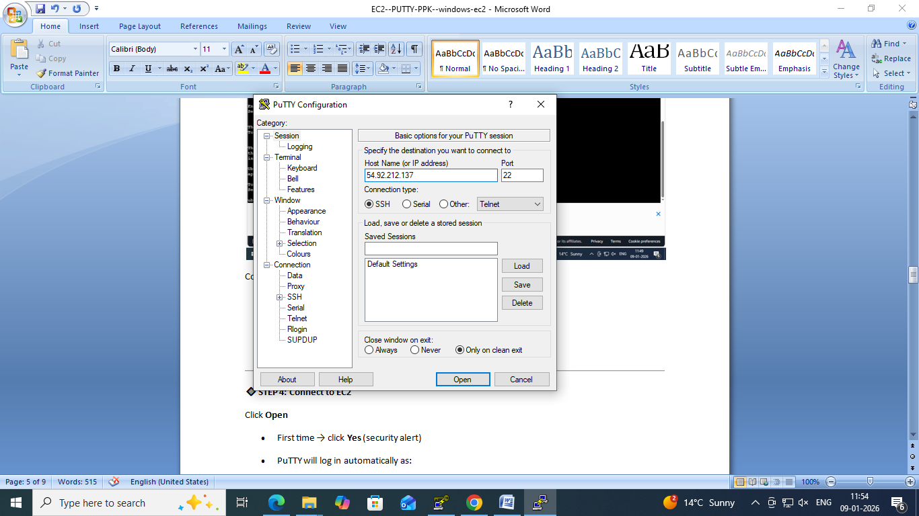

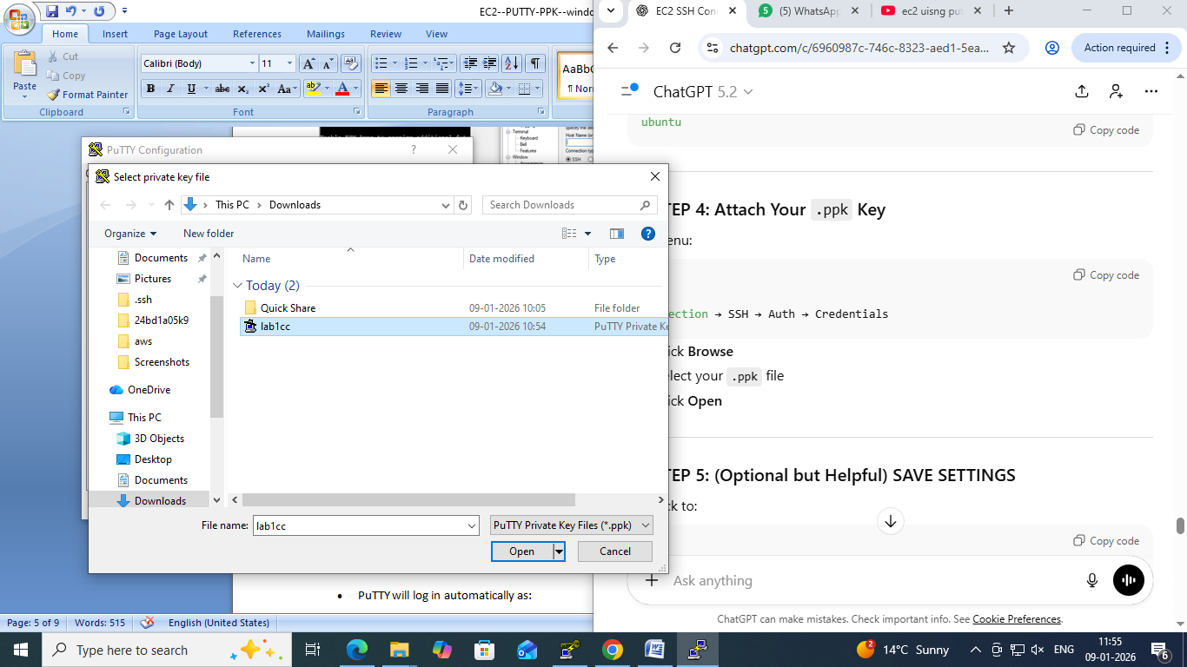

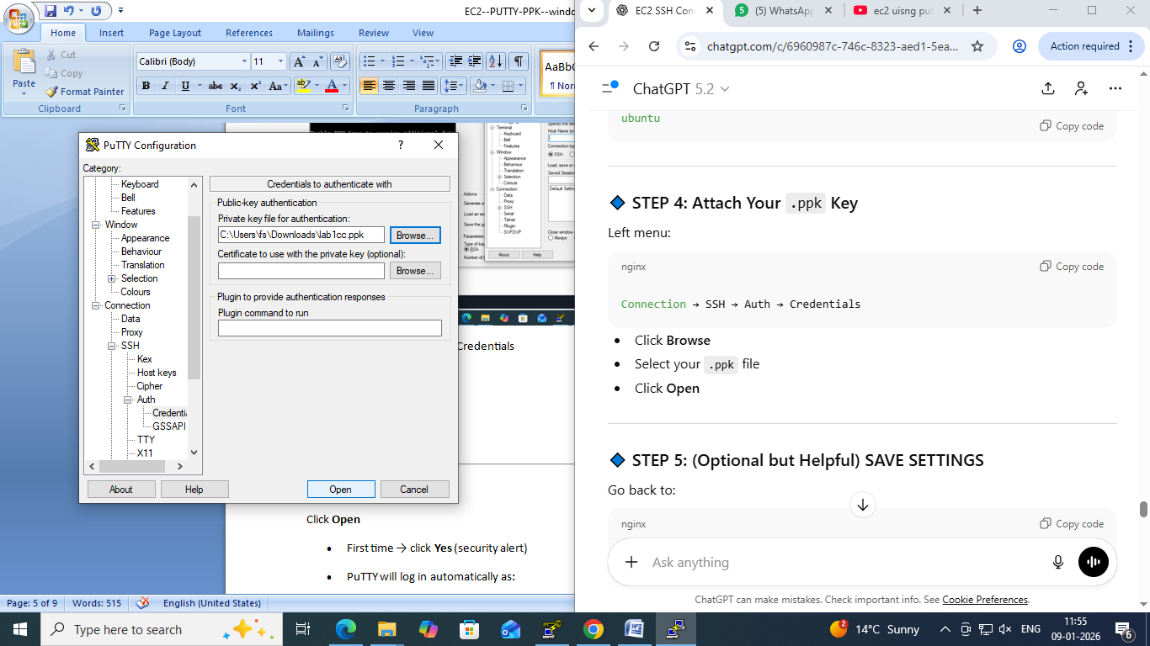

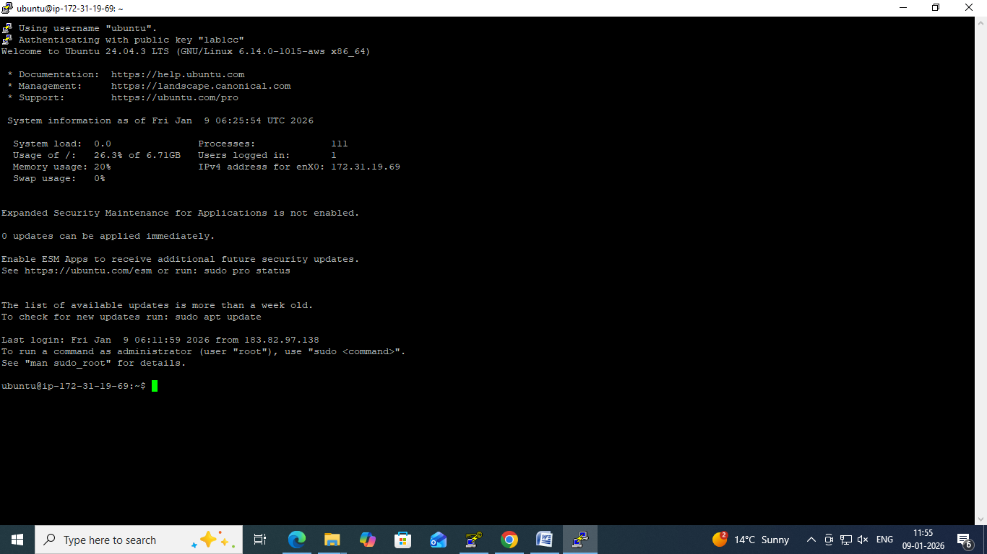

Connection → SSH → Auth → Credentials

1. Click **Browse**
2. Select your **.ppk file**
3. Click **Open**

**🔹 STEP 4: Connect to EC2**

Click **Open**

* First time → click **Yes** (security alert)
* PuTTY will log in automatically as:

ubuntu

🎉**You are now connected to your Ubuntu EC2 instance**

**🧪 VERIFY CONNECTION**

Run:

whoami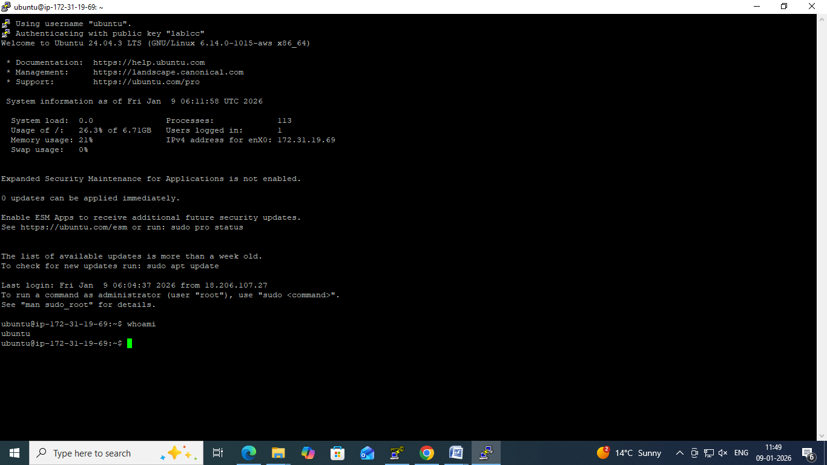

Output should be:

Ubuntu

**Connect EC2 Ubuntu Instance Using PuTTY (Windows) ---USING PEM KEYPAIR**

**PREREQUISITES**

You must have:

* ✅**EC2 Ubuntu instance running**
* ✅**Public IPv4 address** (or Elastic IP)
* ✅**Key pair (.pem file)** used while launching EC2
* ✅**PuTTY &PuTTYgen installed**

👉 Download PuTTY:  
[https://www.putty.org](https://www.putty.org/)

**🔹 STEP 1: Convert .pemto .ppk using PuTTYgen**

PuTTY **cannot use .pem directly**.

**Steps:**

1. Open **PuTTYgen**
2. Click **Load**
3. Select your .pem file  
   (change file type to *All Files*)
4. Click **Open**
5. Click **Save private key**
6. Save as keyname.ppk

✔ Conversion done

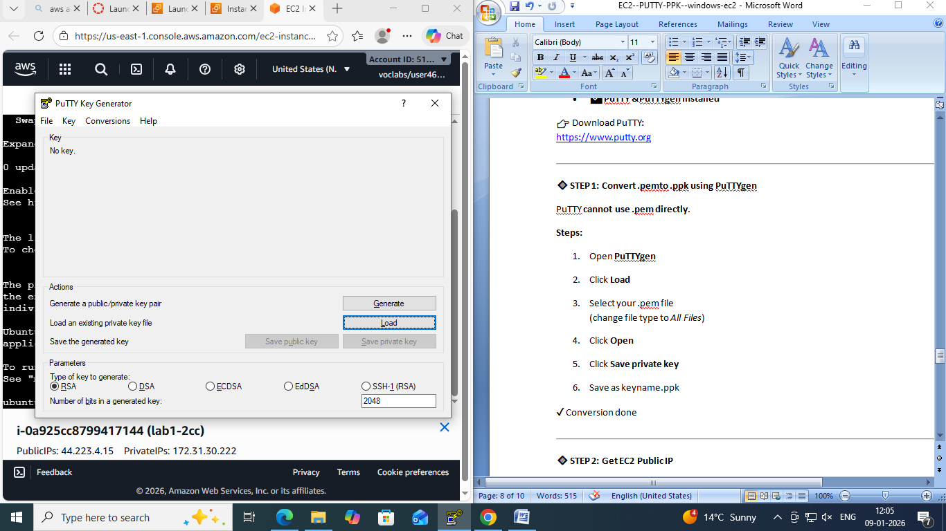

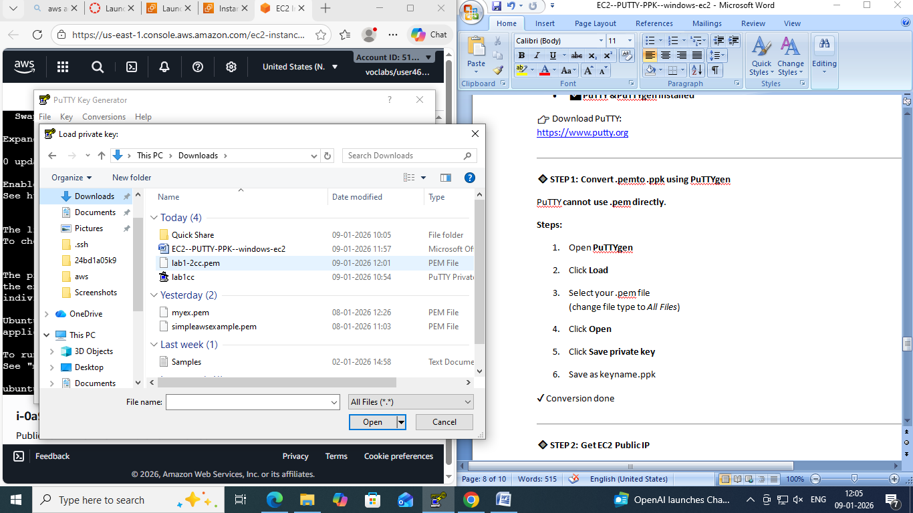

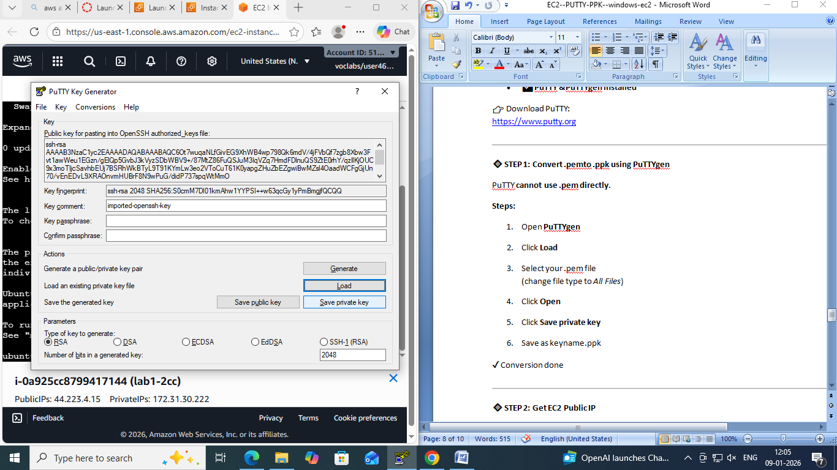

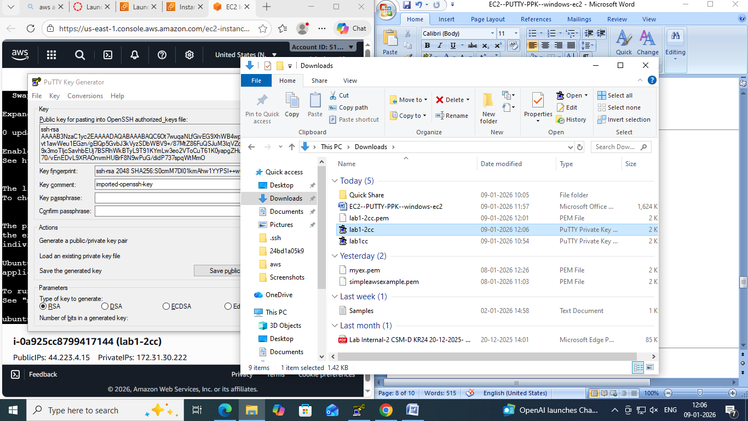

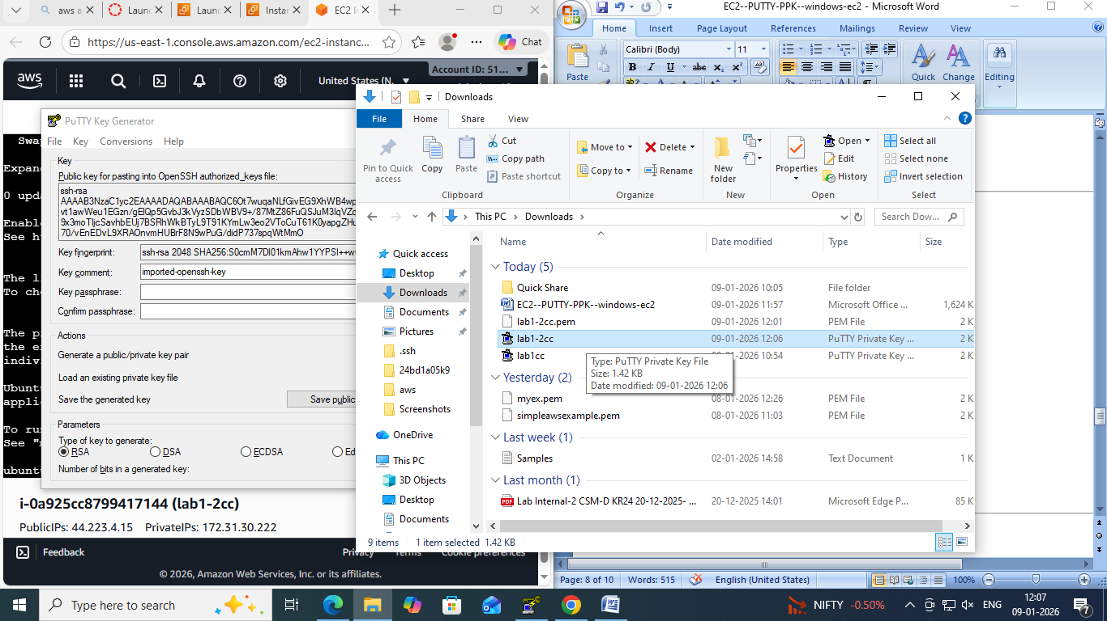

**🔹 STEP 2: Get EC2 Public IP**

Go to:  
**AWS Console → EC2 → Instances---CONNECT –COPY DNS NAME**

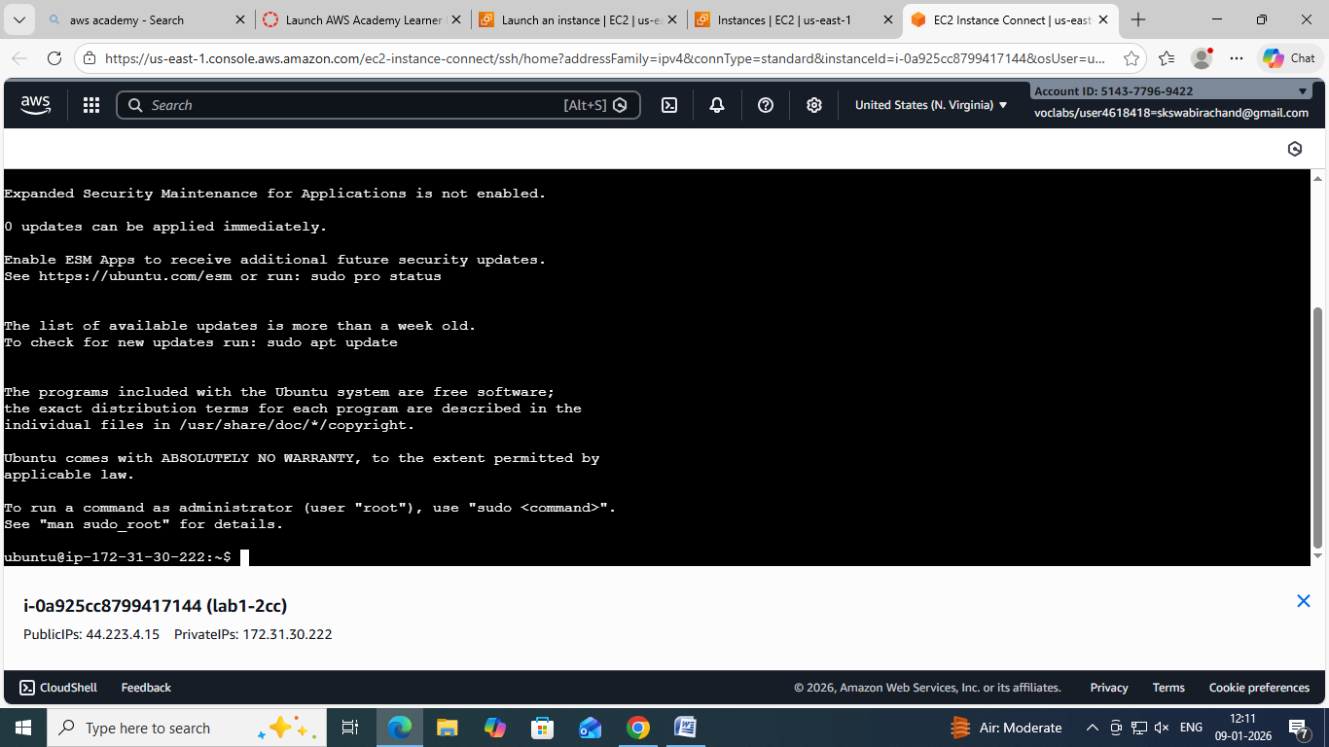

**🔹 STEP 3: Configure PuTTY**

**1️⃣ Open PuTTY**

**Session:**

* **Host Name (or IP address):dns name**

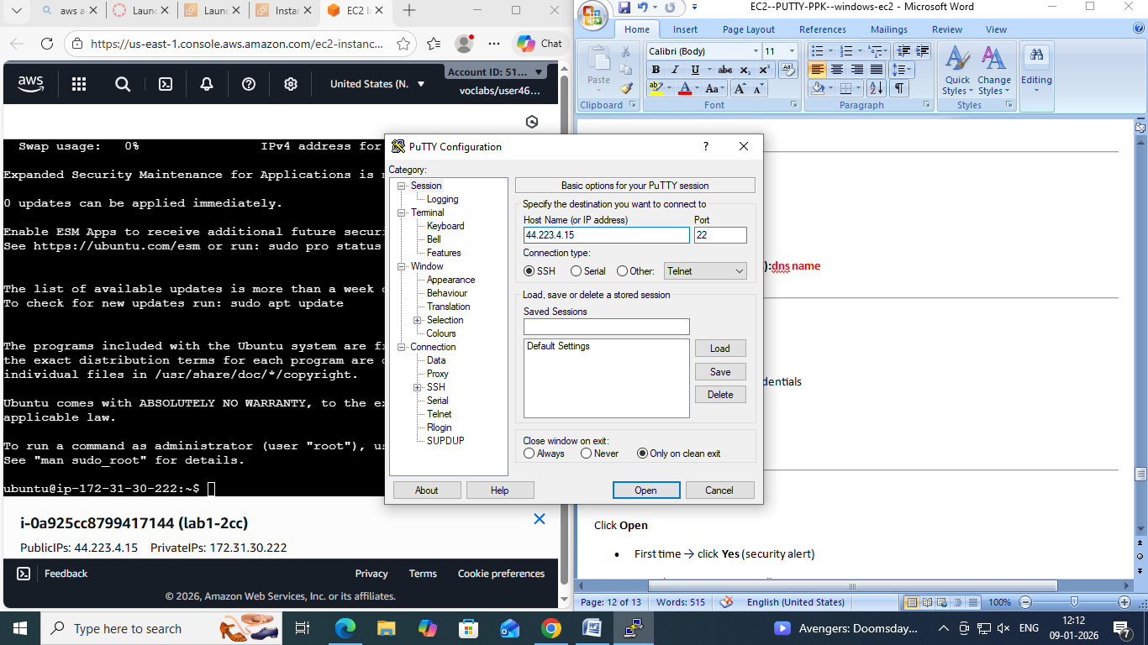

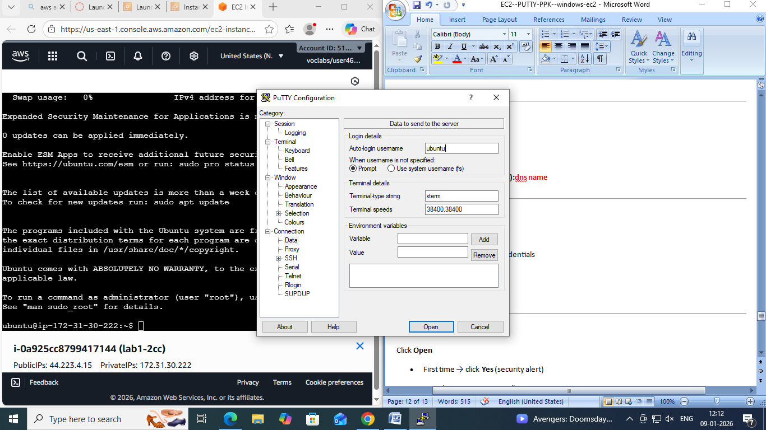

**2️⃣ Load Private Key**

Go to:

Connection → SSH → Auth → Credentials

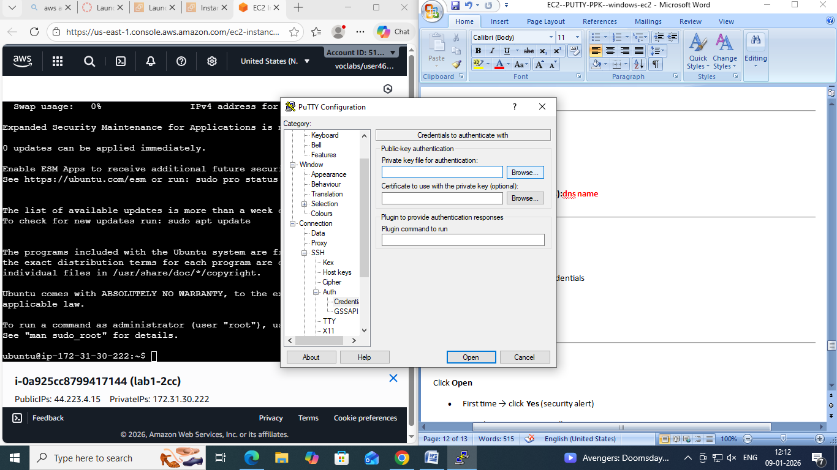

* Click **Browse**

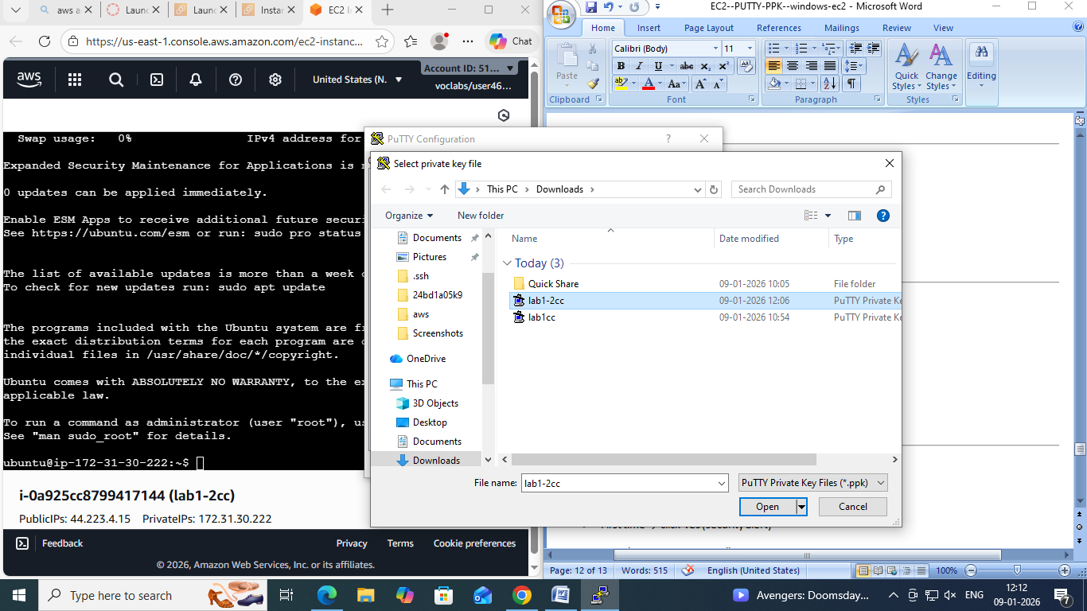

* Select your .ppk file

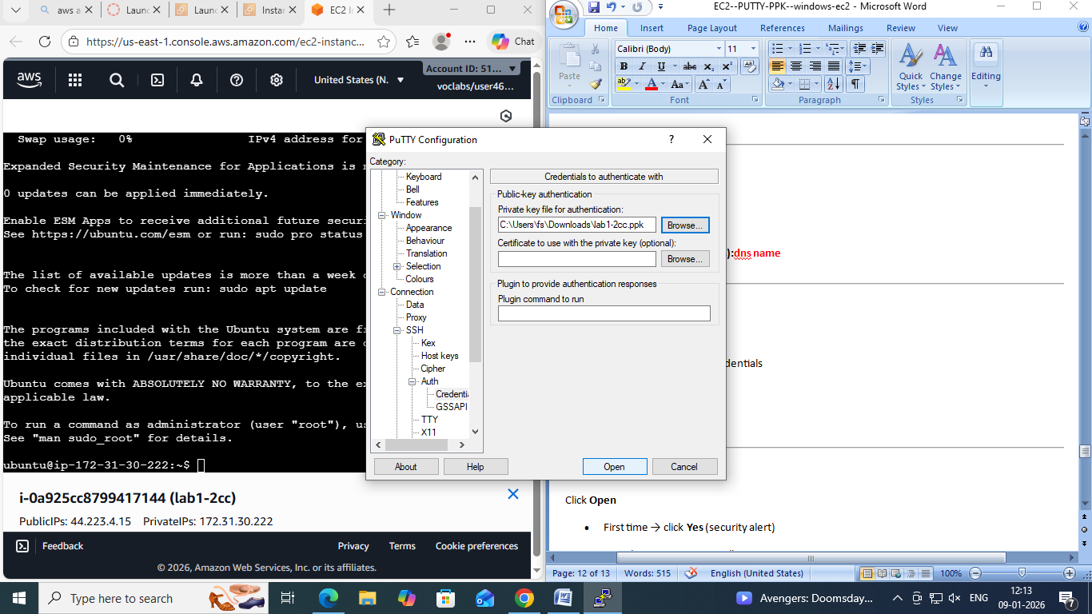

**🔹 STEP 4: Connect**

Click **Open**

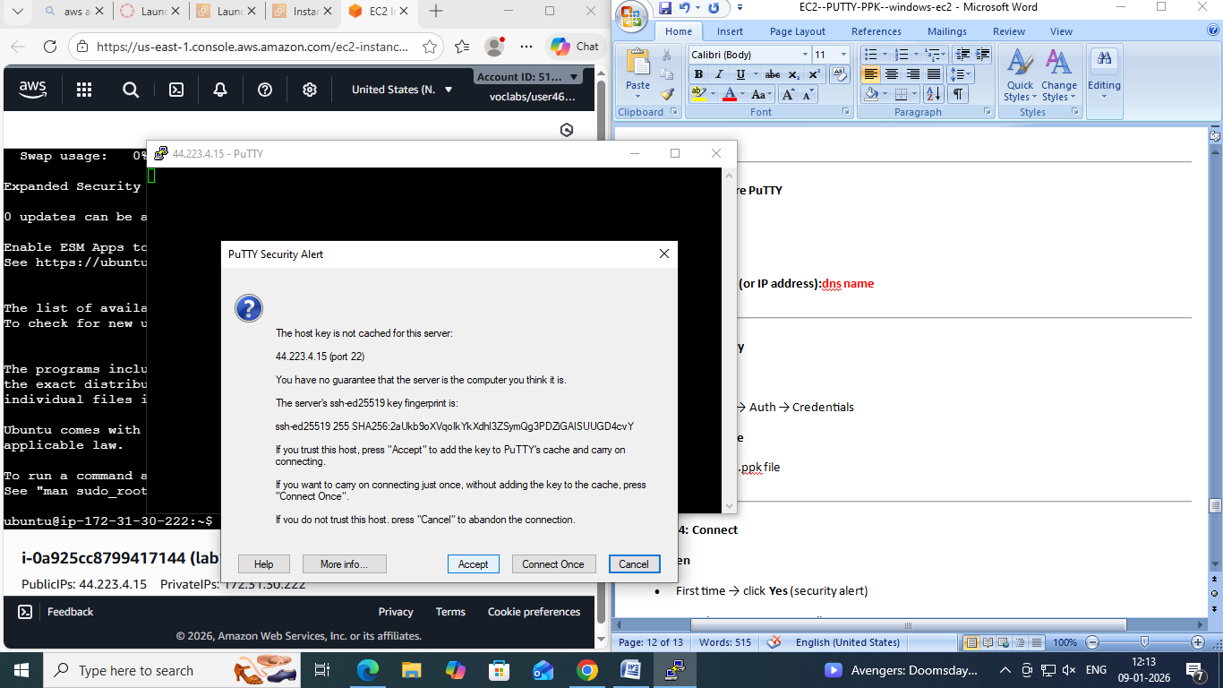

* First time → click **Yes** (security alert)
* Login happens automatically as:

ubuntu

🎉**You are now connected to Ubuntu EC2**

**🧪 VERIFY CONNECTION**

Run:

whoami

Output:

Ubuntu

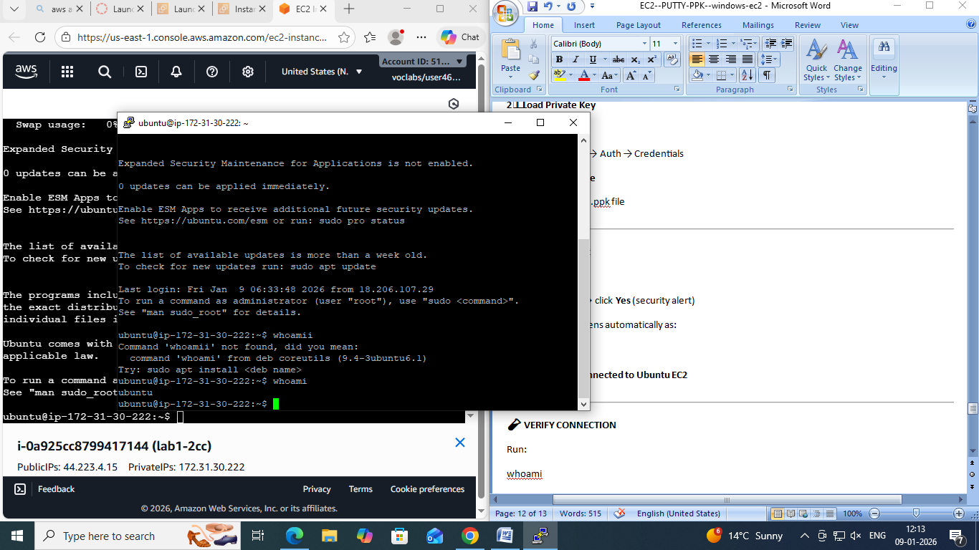

):

**Connecting to EC2 Using AWS CloudShell**

1. **Create the EC2 instance** using a key pair (.pem).
2. **Log in to AWS Console** and click on the **CloudShell** icon (terminal icon on the top-right).
3. Once CloudShell opens, go to **AWS Services → EC2**.
4. Select your **EC2 instance** and click **Connect**.
5. Choose the **SSH client** tab.
6. **Copy the ssh -i command** shown there.
7. **Paste the command in CloudShell** and try to run it.  
   ❌ It will fail with an error like:  
   *“key pair is not available / no such file or directory”*  
   (because the key file is not yet in CloudShell).
8. Now, in **CloudShell**, click on the **“+” (Actions)** icon on the right side.
9. Select **Upload file** and upload the **key pair (.pem)** from your local machine.
10. After upload, **copy the ssh -i command again** from **EC2 → Connect → SSH client**.
11. **Paste and execute the command** in CloudShell.
12. ✅ You are now **successfully connected to the EC2 instance**.

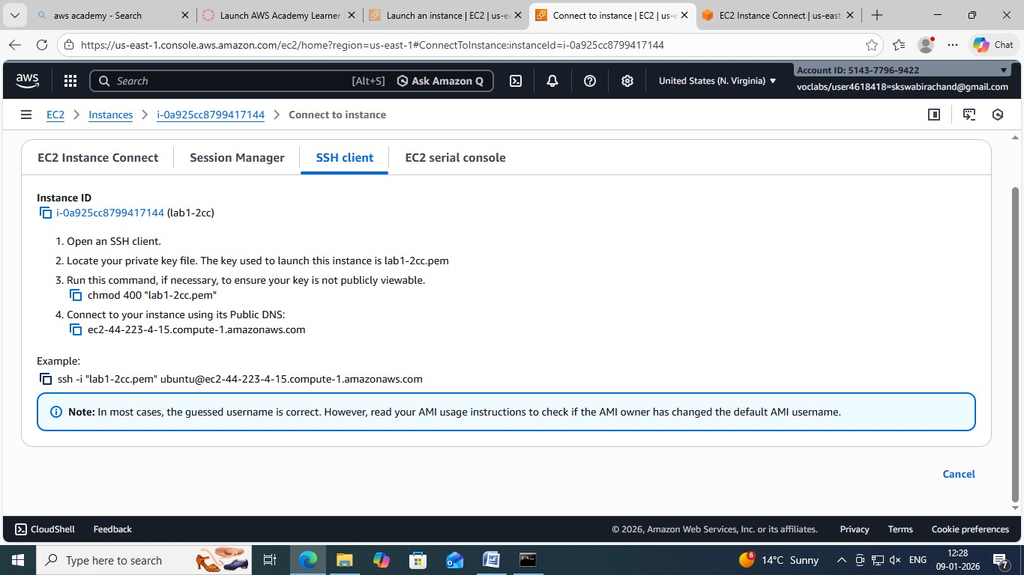

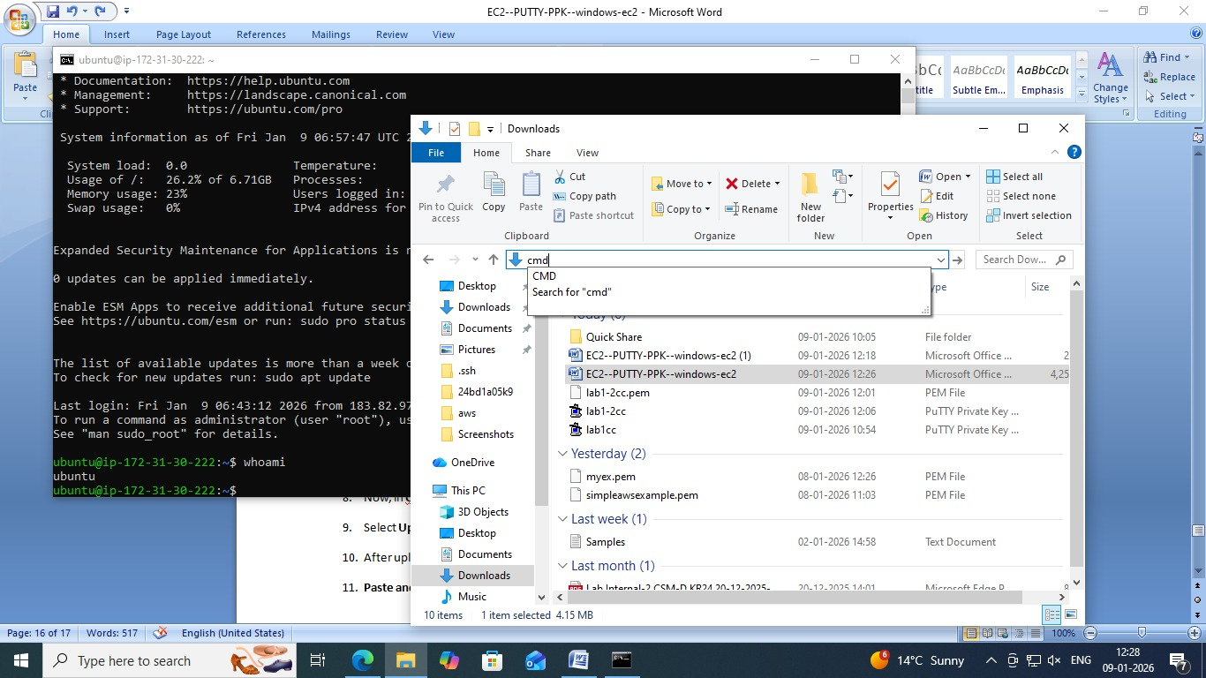

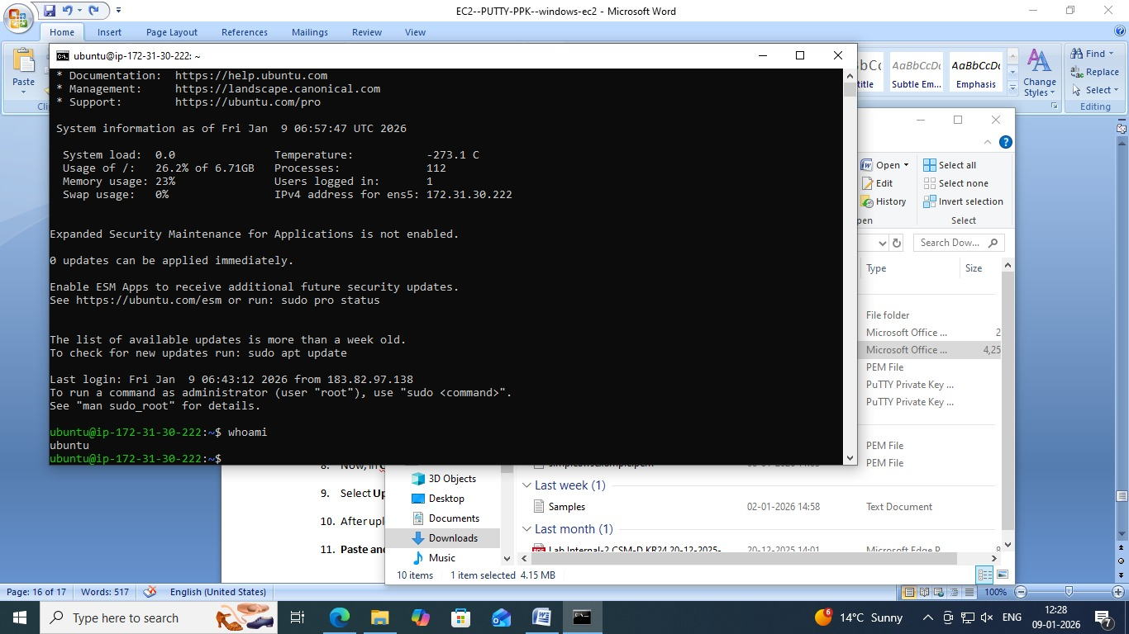

**Step-by-Step: Create Windows EC2 Instance and Connect via RDP**

**Step 1: Launch a Windows EC2 Instance**

1. Log in to your **AWS Management Console**.
2. Navigate to **EC2 → Instances → Launch Instances**.
3. Select an **Amazon Machine Image (AMI)**:
   * Choose a **Windows Server** AMI (e.g., Windows Server 2019 or 2022).
4. Choose an **Instance Type** (e.g., t2.micro for free tier or as per your requirement).
5. Configure **Instance Details** as needed.
6. Add **Storage** if required (default is usually sufficient).
7. Configure **Security Group**:
   * Ensure **RDP port 3389** is allowed.
   * Source can be **My IP** (for security) or a wider range if needed.
8. Select or **create a new Key Pair**:
   * Download the .pem file (keep it safe; it’s needed to decrypt the password).
9. Click **Launch Instance**.

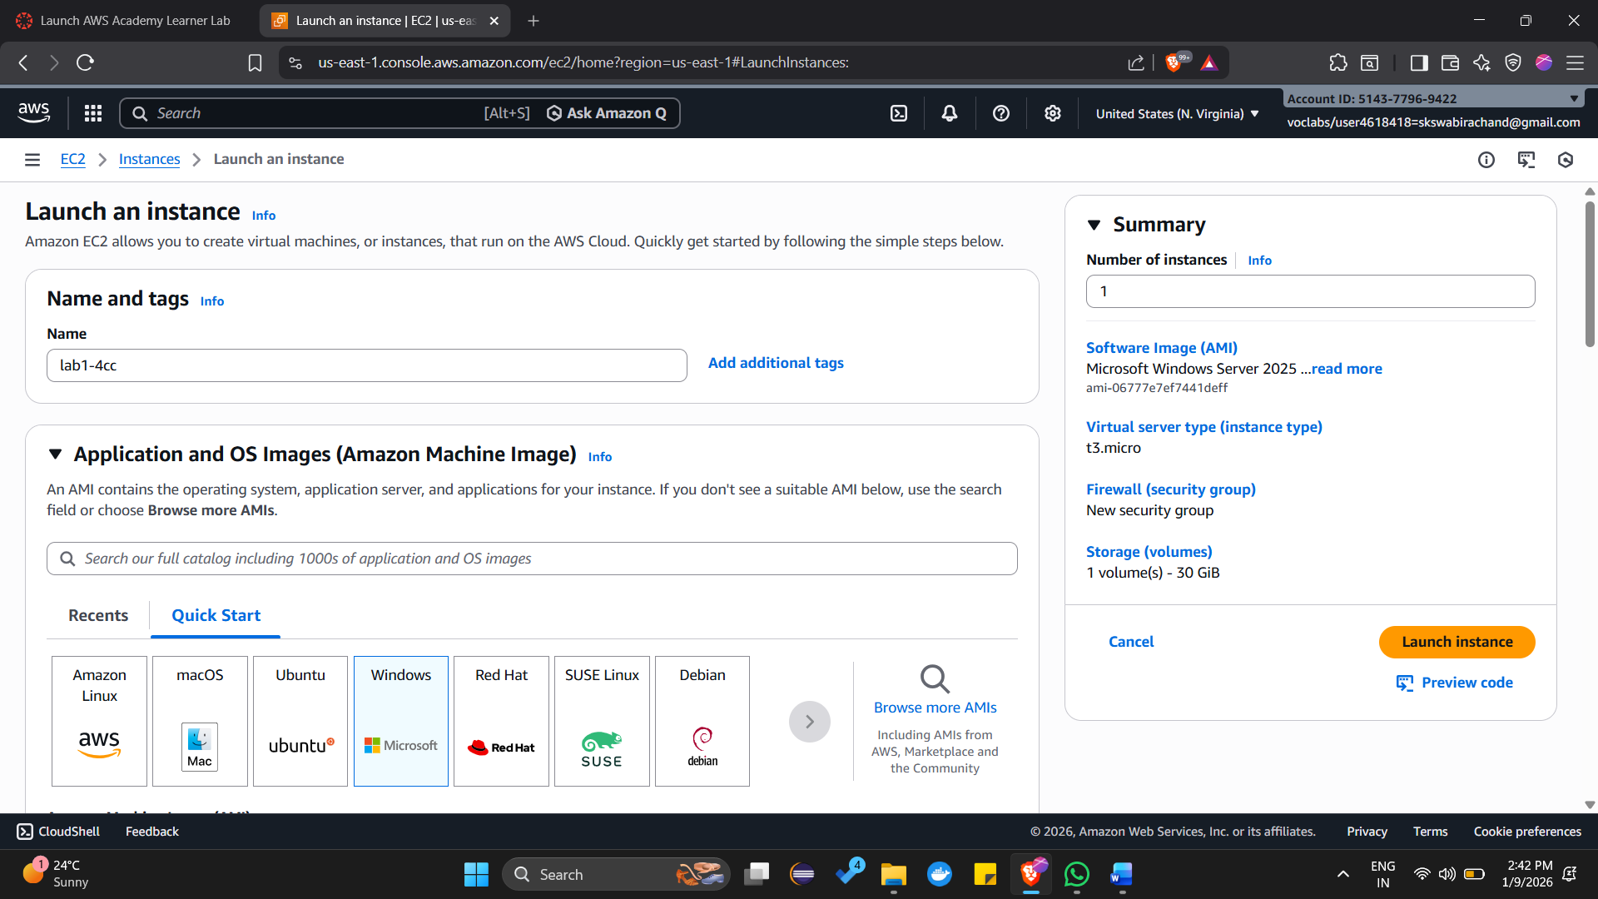

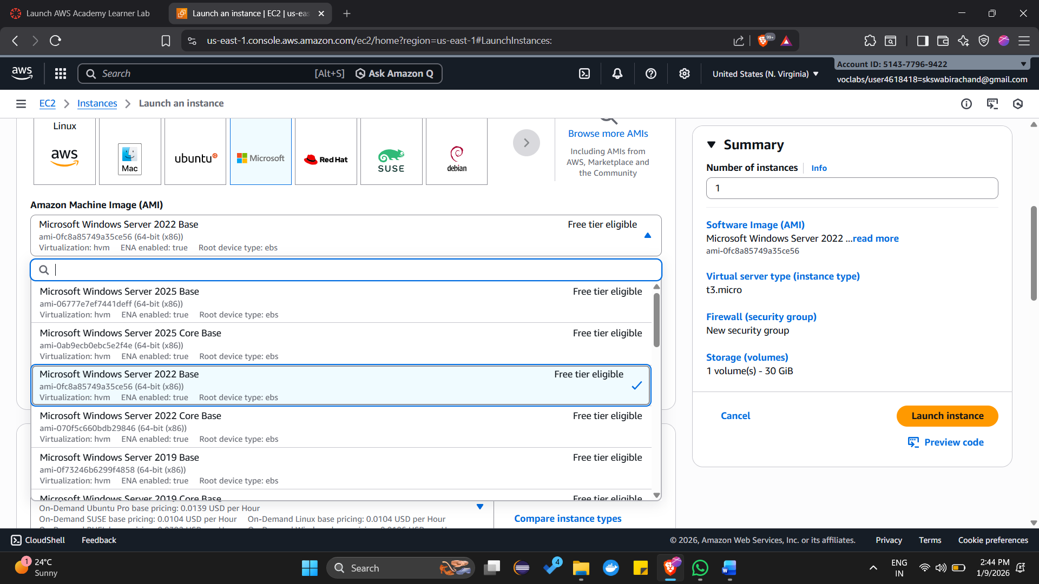

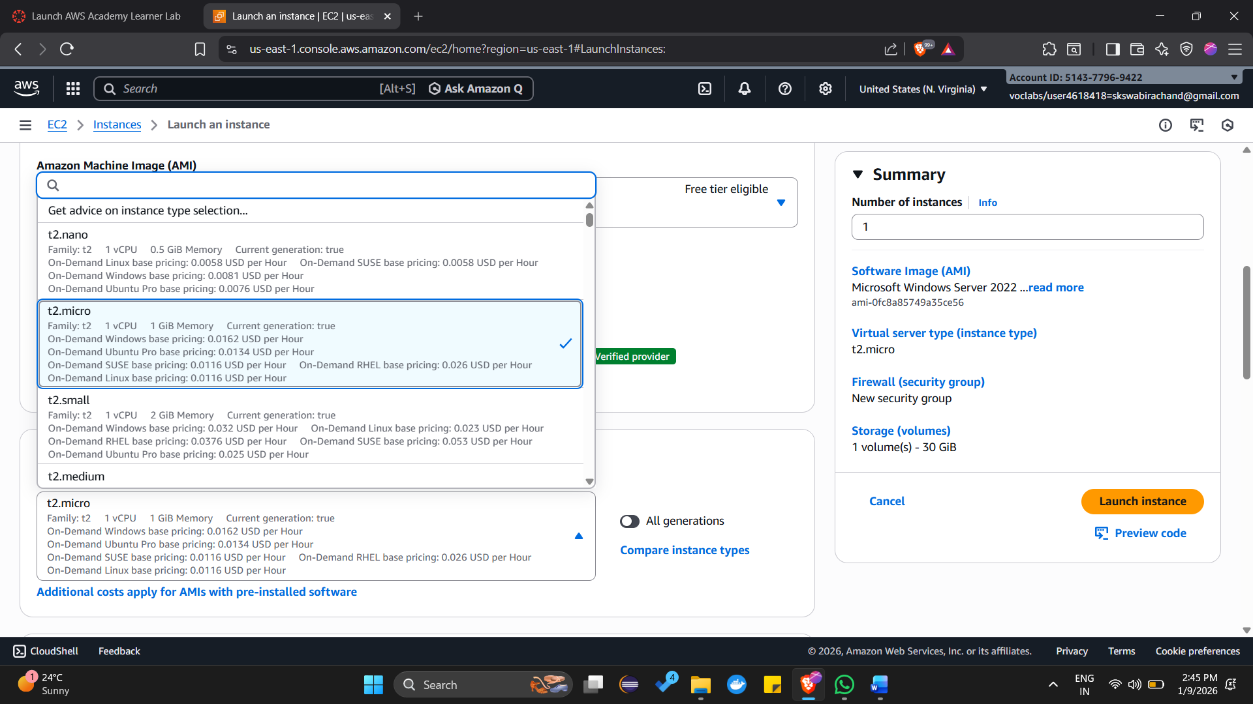

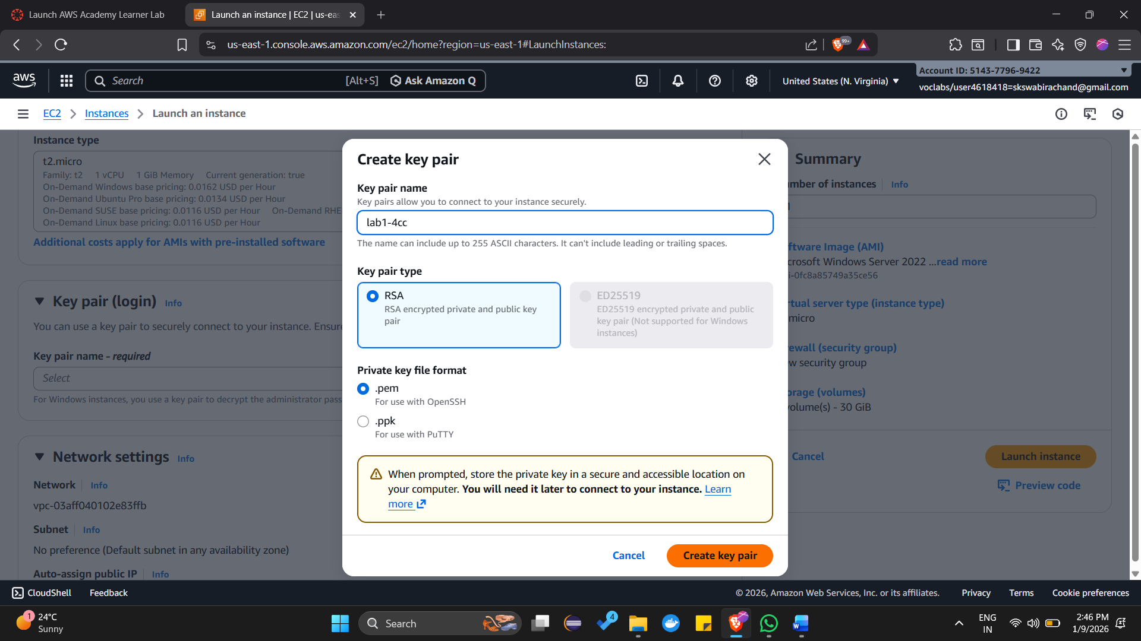

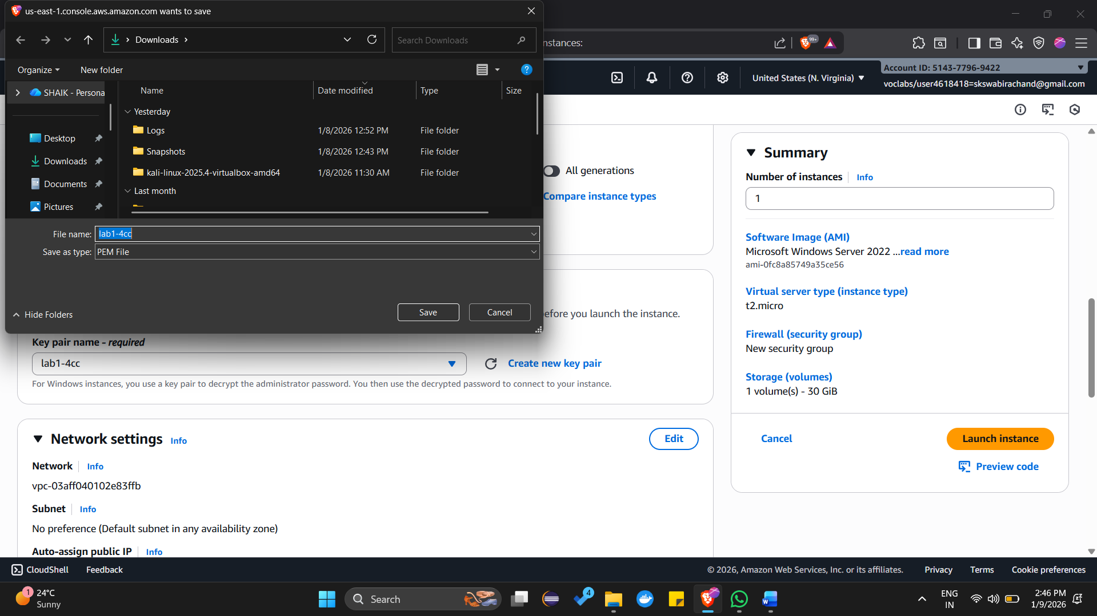

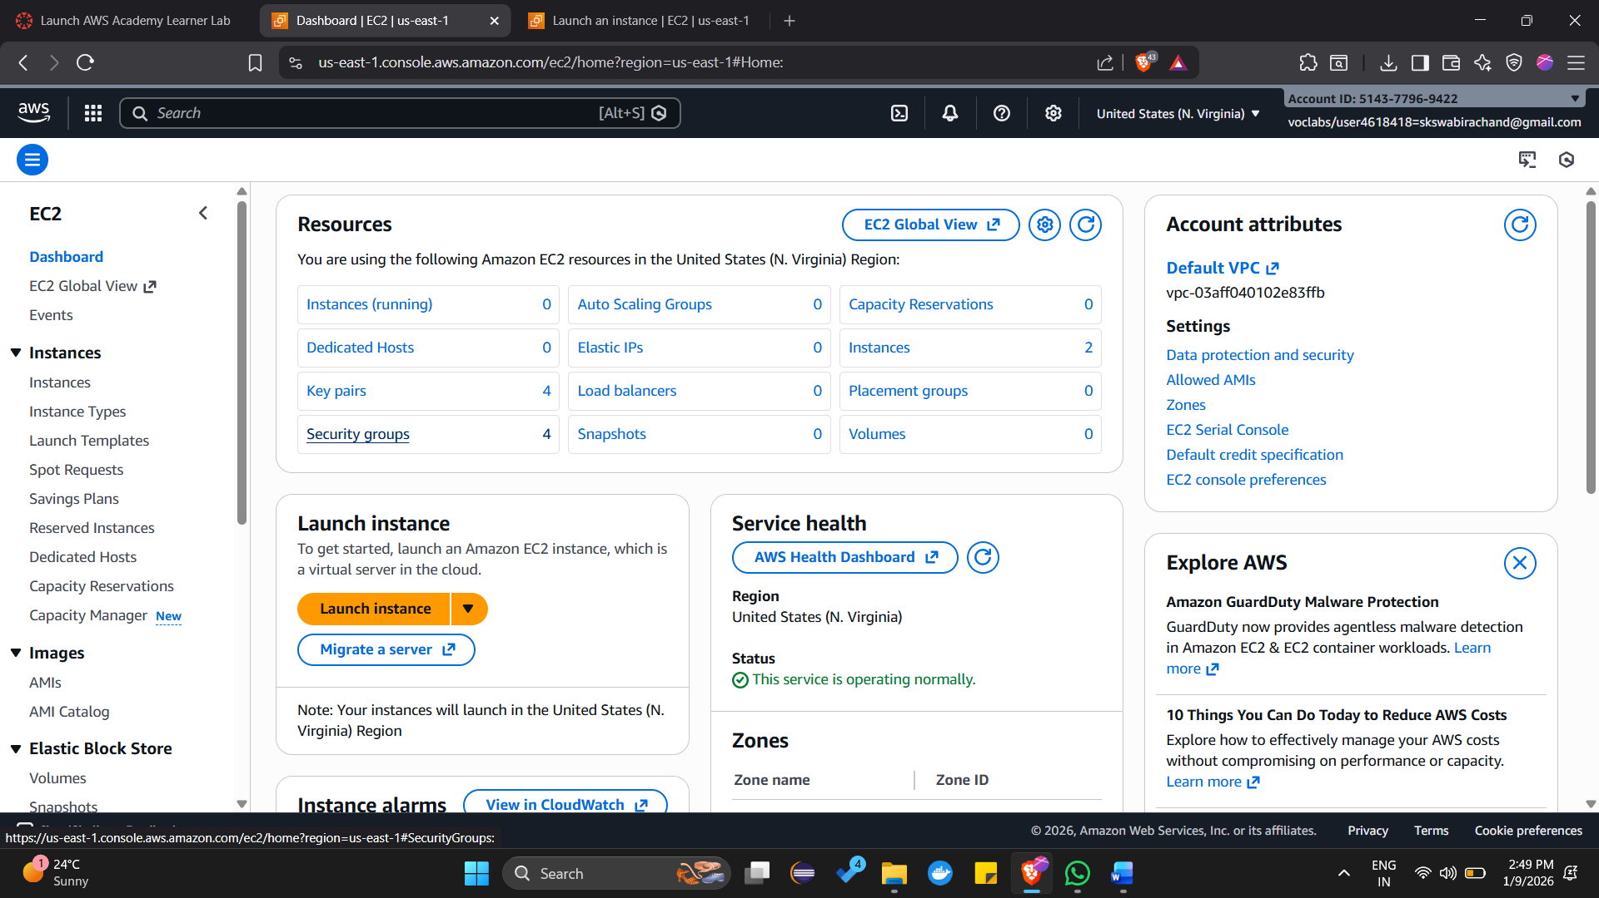

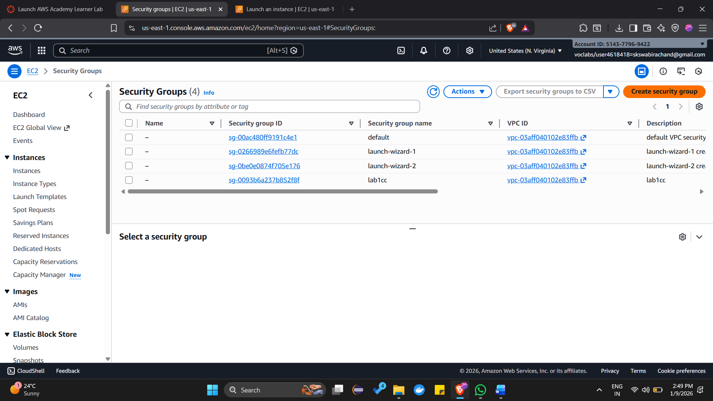

**Step 2: Get the Public DNS / IP**

1. After the instance is running, go to **EC2 → Instances**.
2. Select your instance and note the **Public DNS (IPv4)** or **Public IP**.

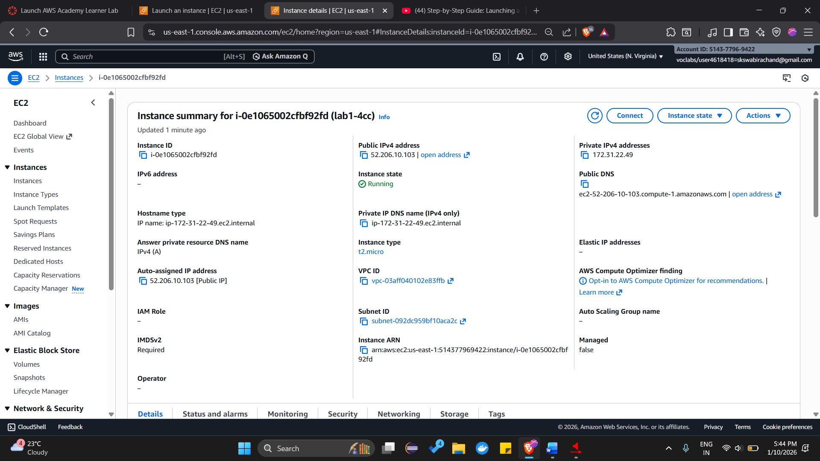

**Step 3: Retrieve the Windows Administrator Password**

1. Select your instance → Click **Connect → RDP Client**.
2. Click **Get Password**.
3. Upload your **Key Pair (.pem) file**.
4. Click **Decrypt Password**.
5. Copy the **Administrator password** shown.

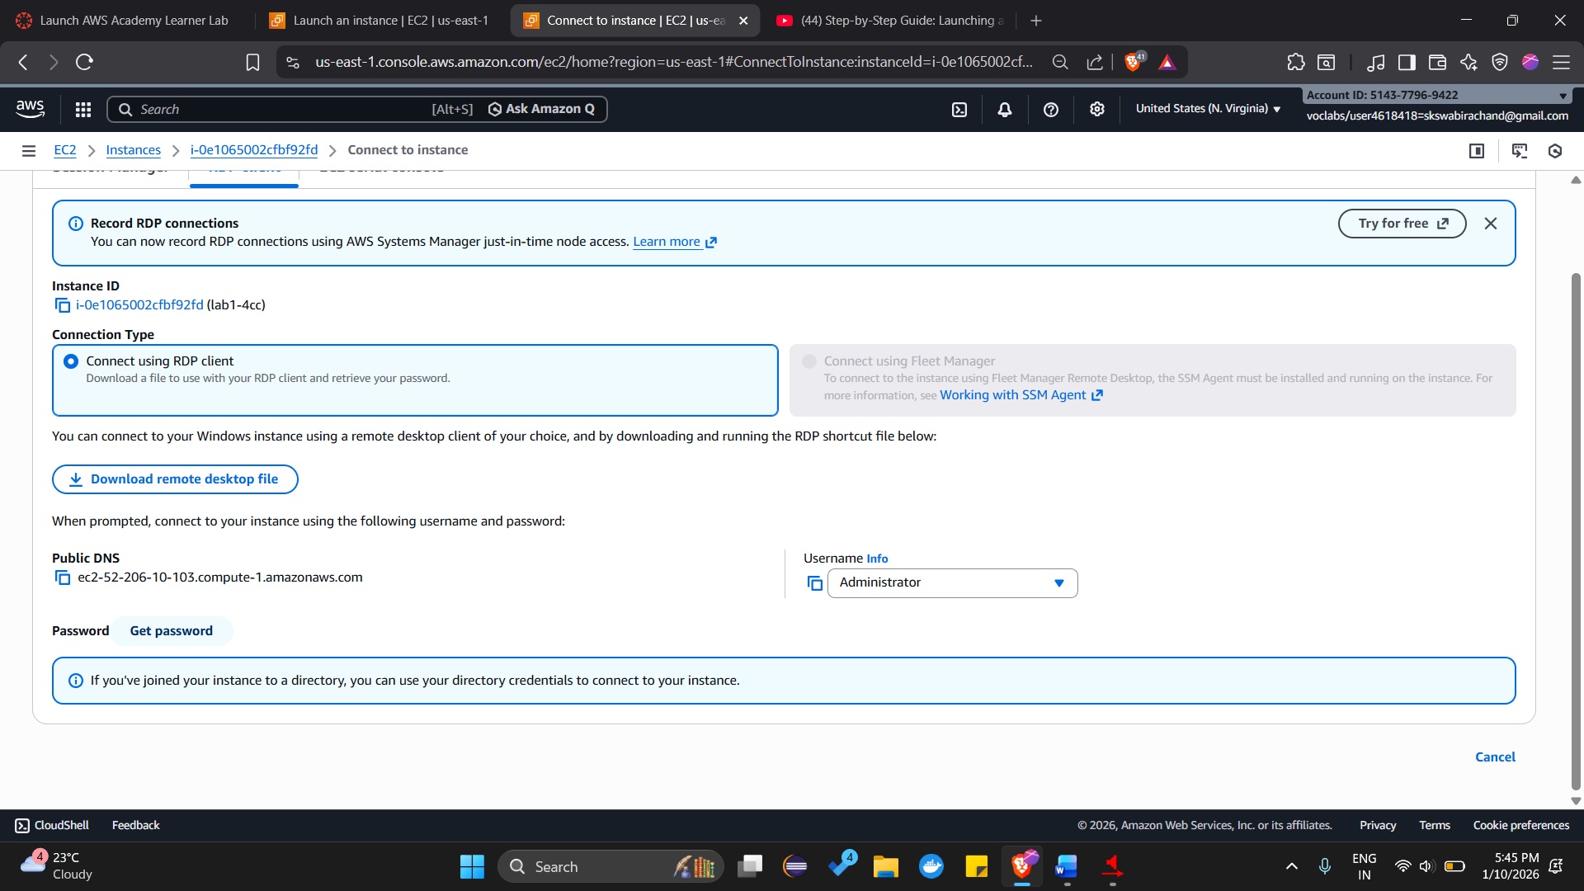

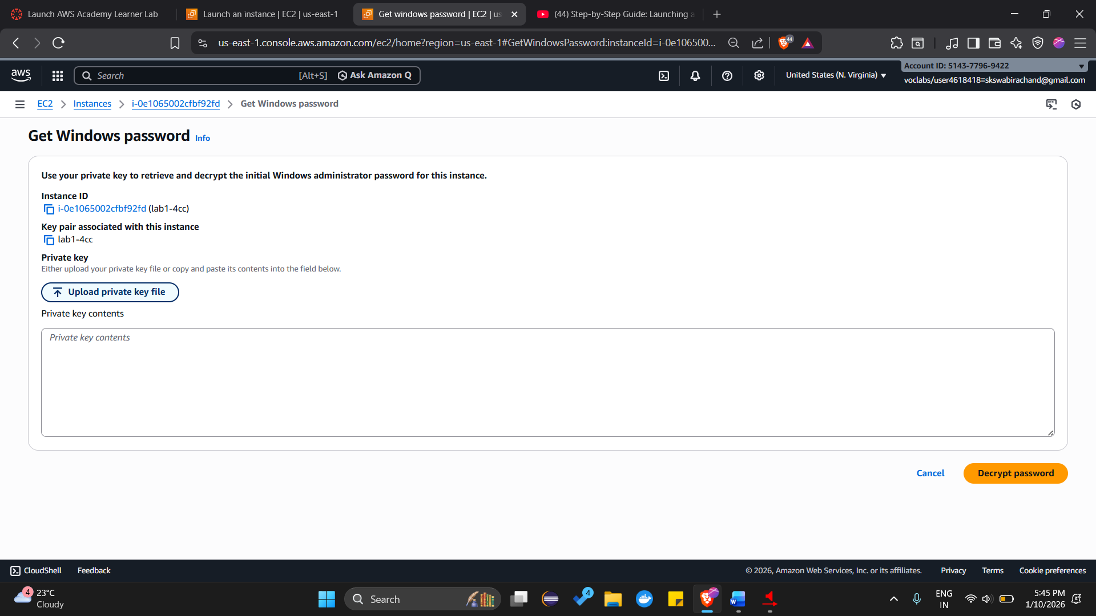

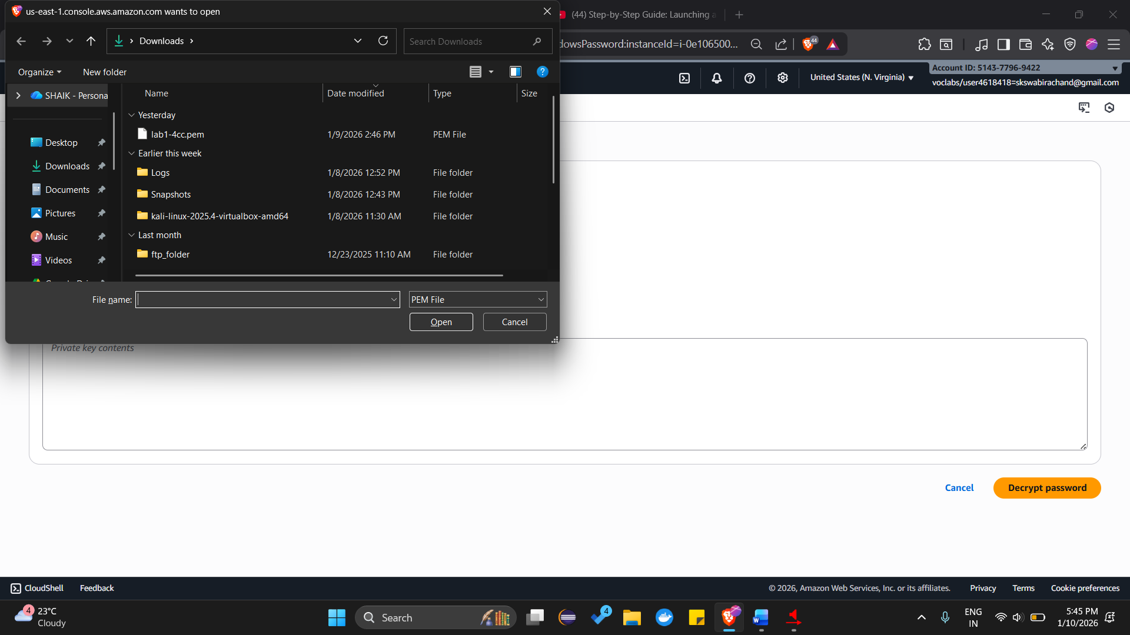

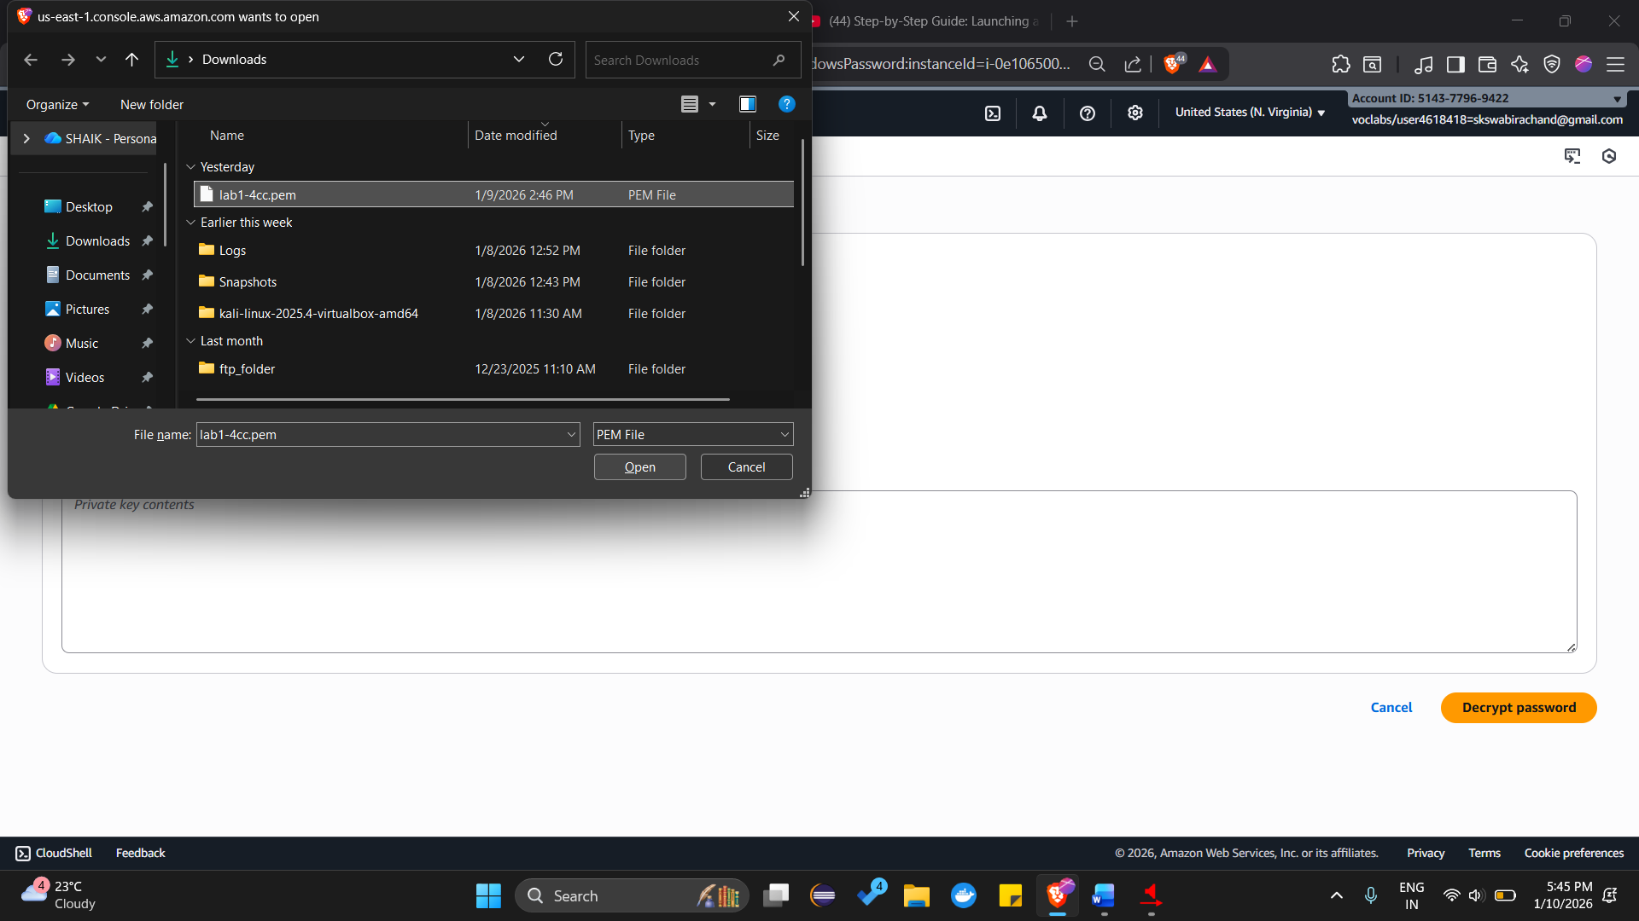

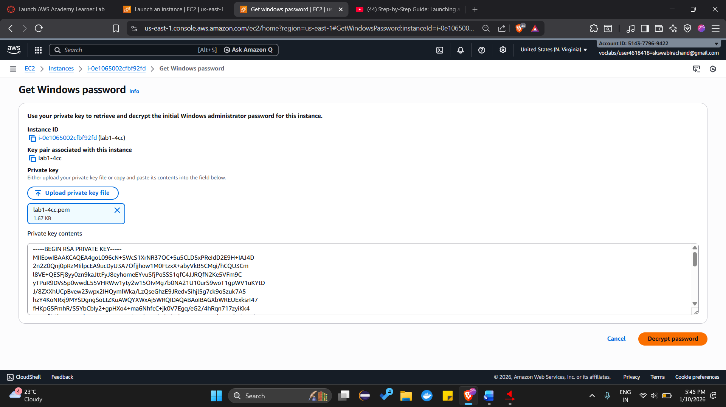

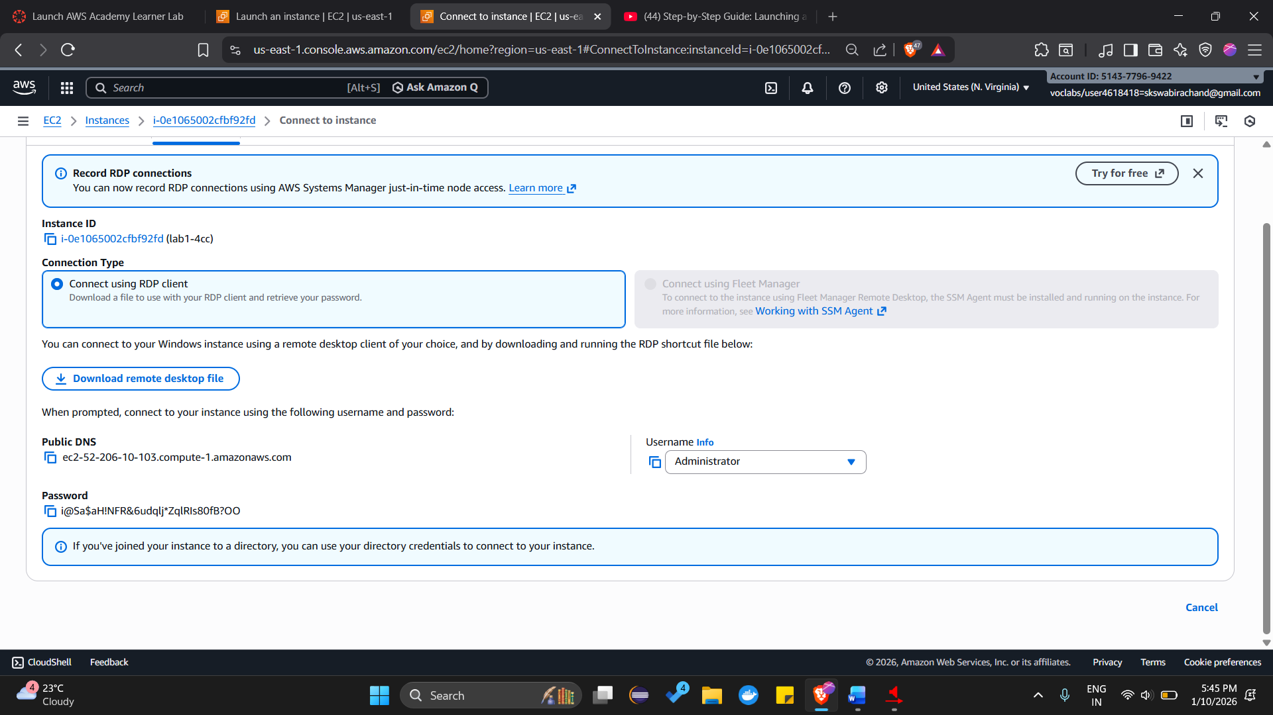

**Step 4: Connect via RDP**

1. On your **local Windows machine**, open **Remote Desktop Connection** (mstsc).
2. In the **Computer** field, enter the **Public DNS** or **IP address** of the EC2 instance.
3. Click **Connect**.
4. In the login prompt:
   * **Username**: Administrator
   * **Password**: Paste the decrypted password from Step 3.
5. Click **OK**.

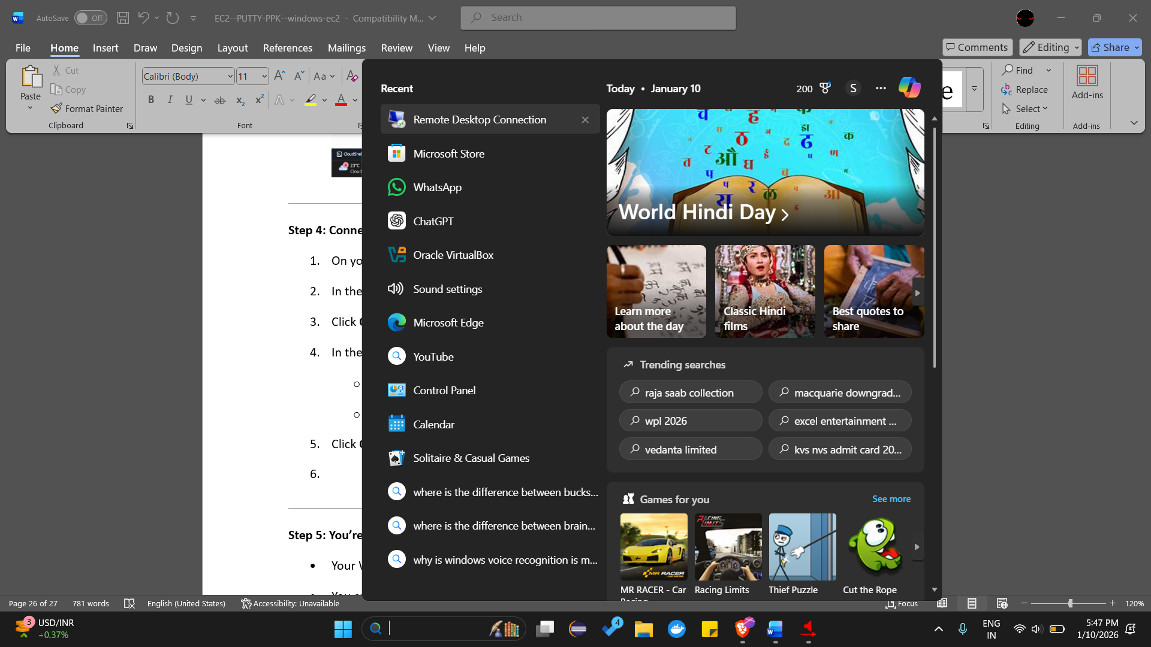

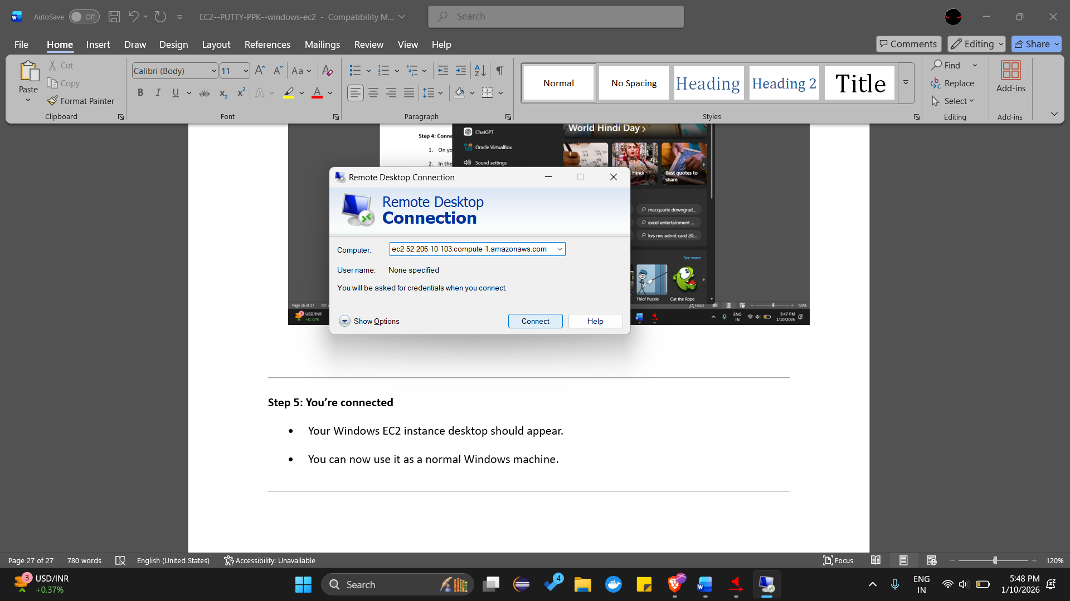

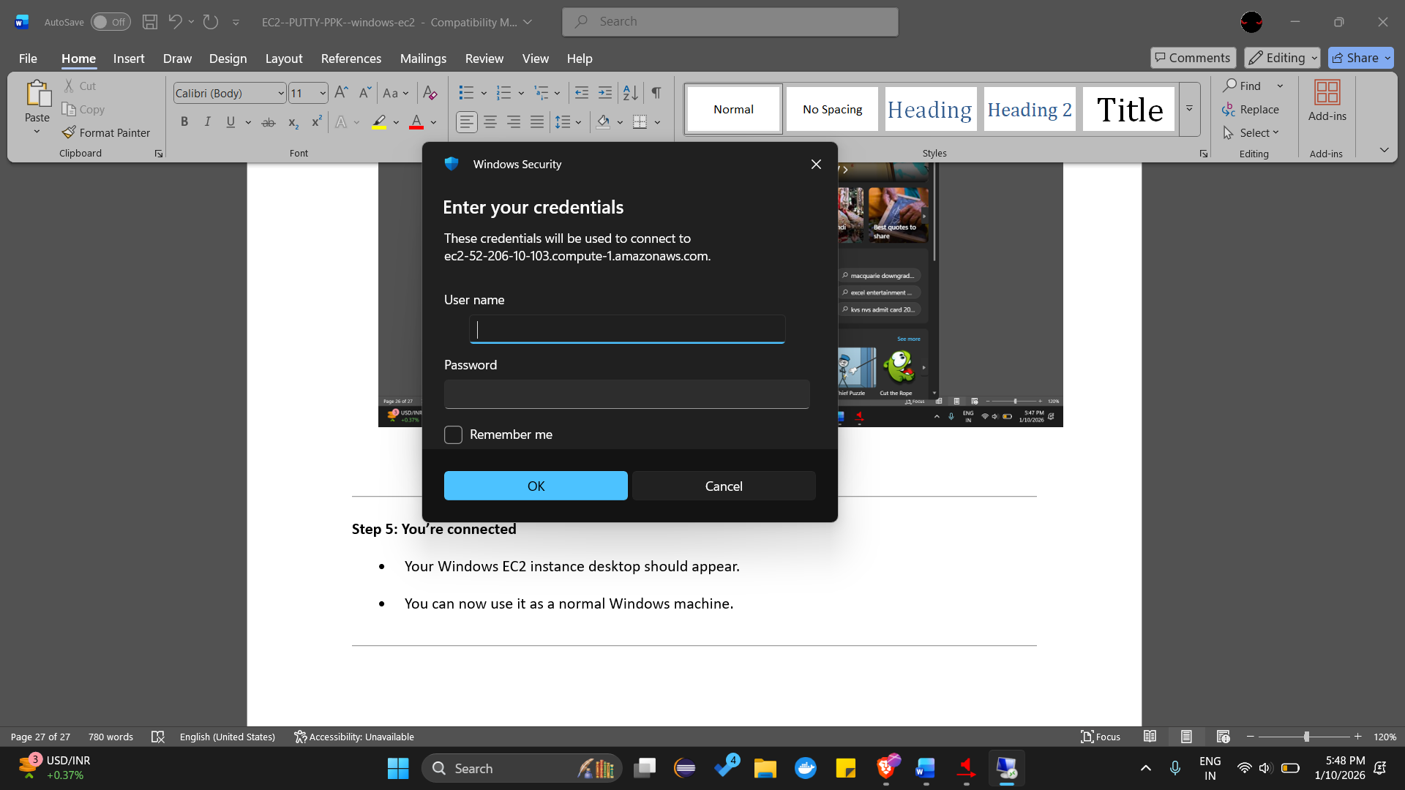

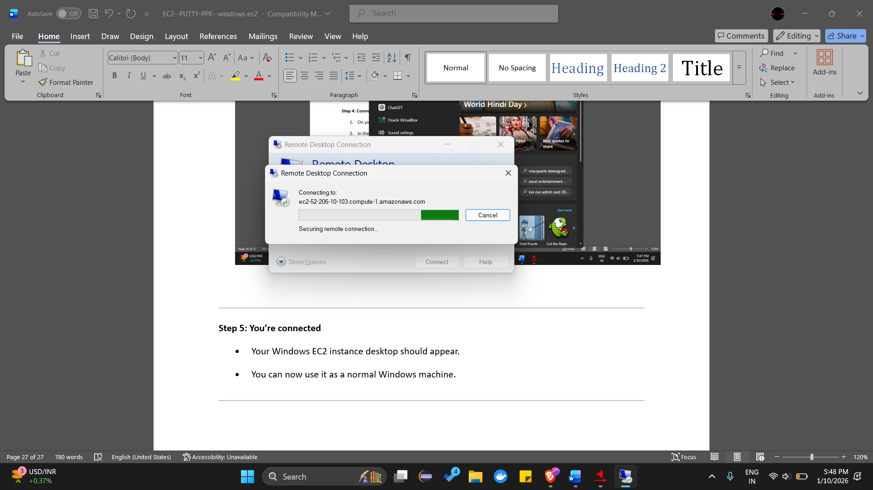

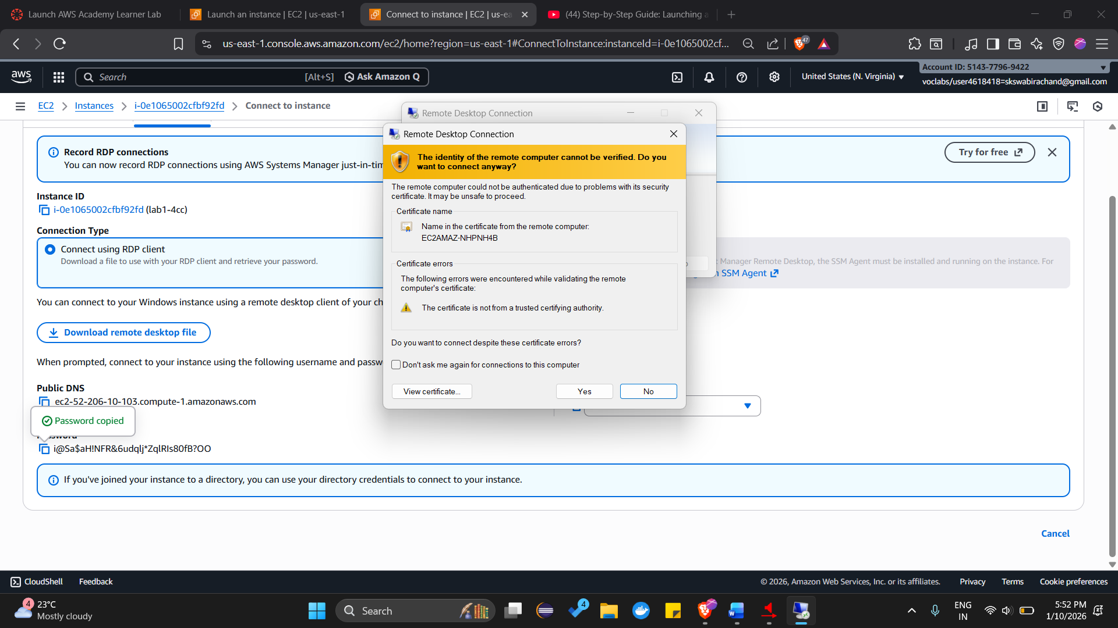

**Step 5: You’re connected**

* Your Windows EC2 instance desktop should appear.
* You can now use it as a normal Windows machine.

